Simple and Easy Questions

- Write a C++ program that defines a structure to store a student's name, 5 test scores, and calculates the average score. The program should prompt the user for the student's name and test scores, then display the name, the scores (with two decimal places), and the average score (also formatted to two decimal places).

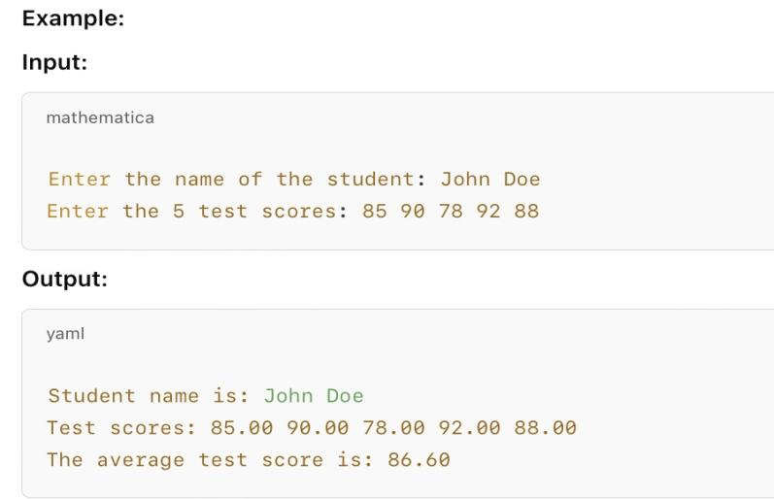

- Write a C++ program to simulate a restaurant ordering system where the user can select from 8 breakfast items, specifying the quantity for each. The program should display a receipt with the quantity, item name, price, total cost, tax (5%), and the final amount (including tax). The user can continue selecting items or exit. Proper formatting should be applied for the amounts.

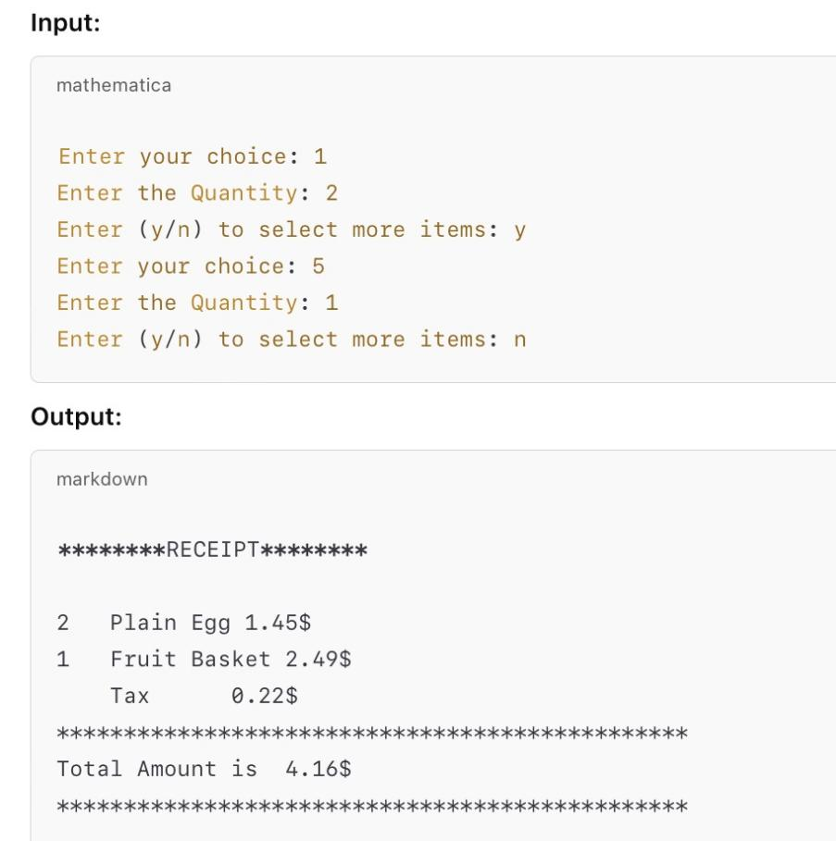

- Write a C++ program to calculate the billing price for Residential and Business customers.
- Residential bill includes a $4.50 processing fee, $20.50 basic service fee, and $7.50 per premium channel.
- Business bill includes a $15.00 processing fee, $75.00 basic service fee for up to 10 connections (plus $5 for each additional connection), and $50.00 per premium channel.
The program should prompt for customer type, account number, premium channels, and connections (if applicable), then display the total bill.
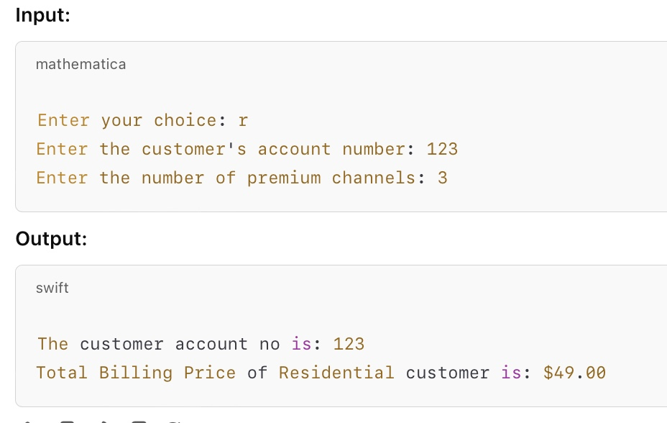
- Create a program simulating a glass with an initial liquid level of 200 ml. The user can request a specific amount of drink. If the remaining liquid is less than 100 ml, the glass is refilled automatically to 200 ml. After refilling, the user is prompted whether they want to take another drink or not. The process repeats until the user chooses to stop.
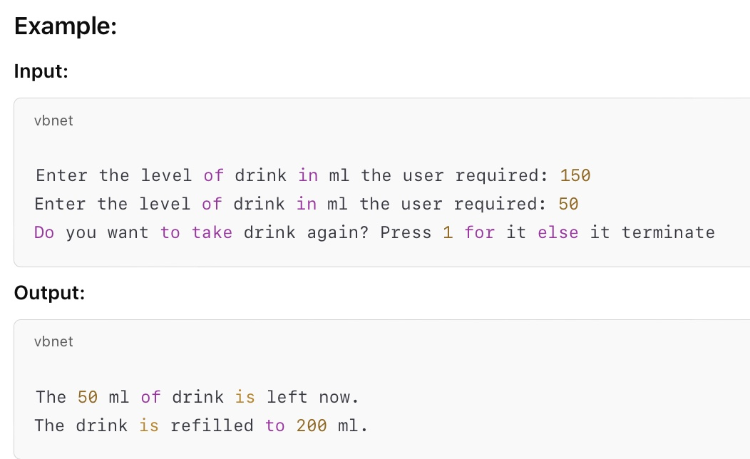

- Design a program to manage book information. The program should store the details of 3 books including the book's name, ISBN, author's name, and publisher's name. After entering the book details, the user can search for a book by its ISBN. If a matching ISBN is found, the program will display the book's details.

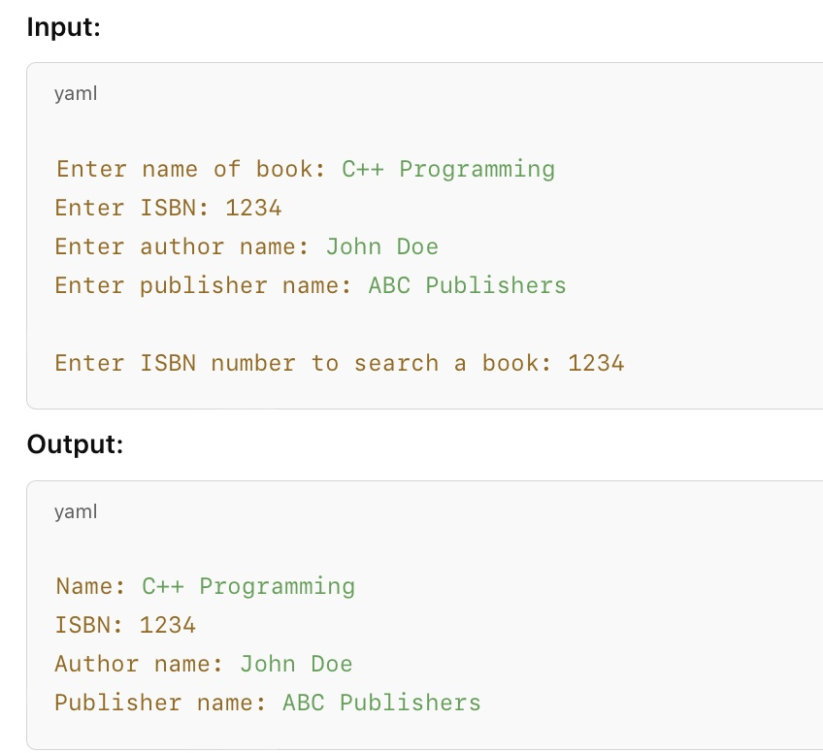

- Write a C++ program to calculate the area and perimeter of a circle. The program should:
- Use a parameterized constructor to initialize the radius.
- Calculate and display the area (πr²⁾ and perimeter (2πr) with two decimal places.
- Demonstrate the use of a destructor.
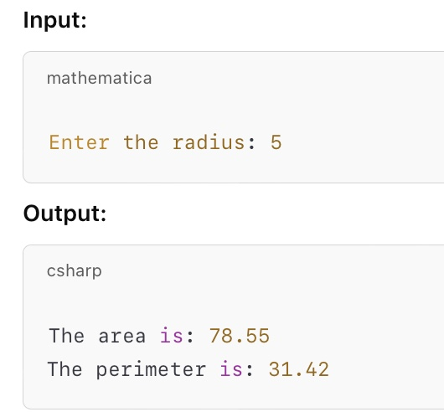

- Create a C++ program to simulate a basic banking system with the following features:
- Add Balance: Deposit a specified amount into the account.
- Withdraw Balance: Withdraw a specified amount, checking if the balance is sufficient.
- Show Balance: Display the current balance.
- The program should repeatedly display a menu for the user to choose an action until an invalid option is entered.
The initial account balance is 9999.

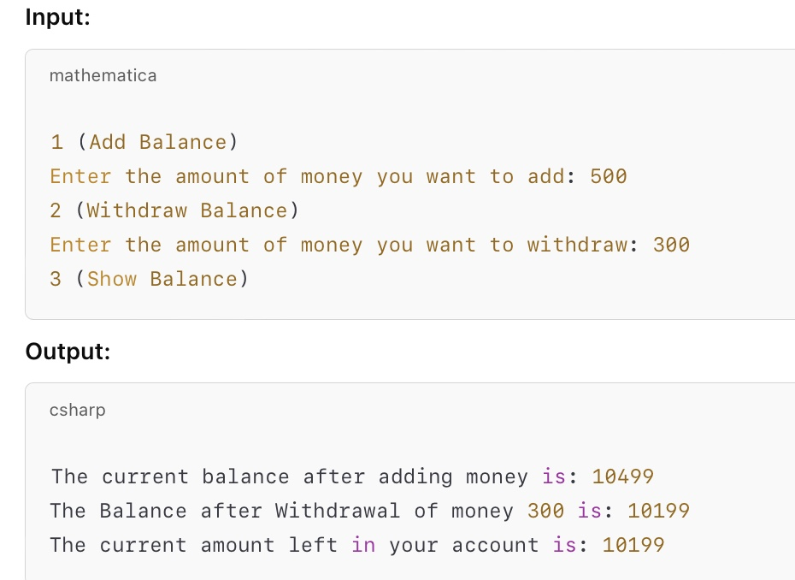
- Write a C++ program that simulates generating an invoice for a hardware store. The program should:
- Ask the user for the number of products.
- For each product, input the name, description, quantity, and price.
- Display each product's details (name, description, quantity, and price).
- Calculate and display the total amount for all products, with the price displayed to two decimal places.
The program should include a class invoice that handles input and calculates the total. Here's an example output:

- Write a C++ program to manage a book inventory. The program should:
- Display Books: Show a list of books with their author, title, price, publisher, and stock.
- Search and Buy Books: Allow the user to search by author and title. If available, let the user specify how many copies to buy. If the quantity exceeds stock, prompt for a valid amount and show the total cost.
- Menu Options: Provide options to display books, search, or exit.
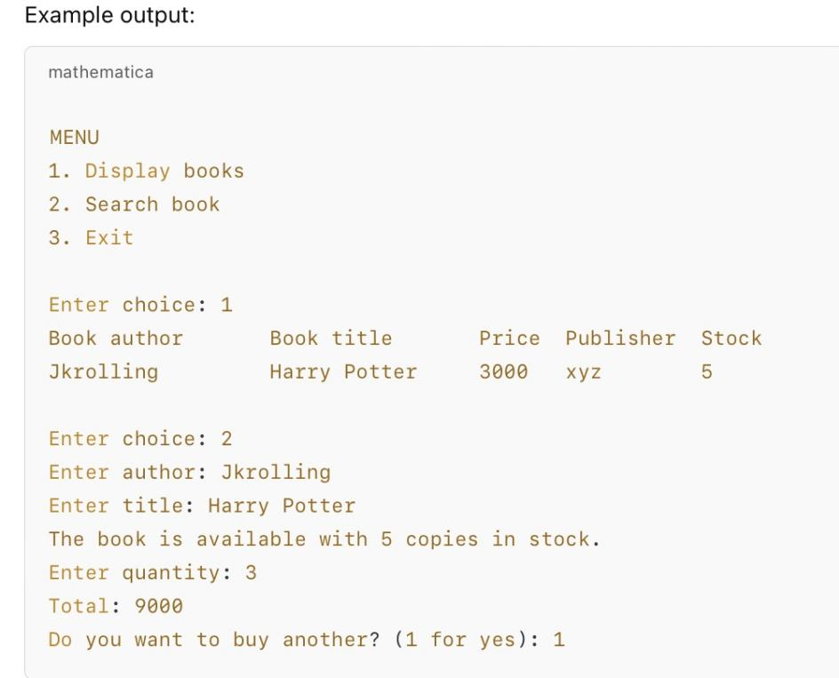
- Create a Coffee Shop Order Management System in C++. The system should allow customers to view a menu, place orders, calculate totals, and fulfill orders.
Requirements:
- Menu Display: Show three items (Pizza, Pasta, Coffee) with their prices.
- Order Placement: Customers select an item and enter the quantity. The system calculates the total cost.
- Order Fulfillment: Track if orders are fulfilled. Display the order details, including item name, quantity, and total amount.
- Output: Confirm order readiness or show a message if all orders are fulfilled.

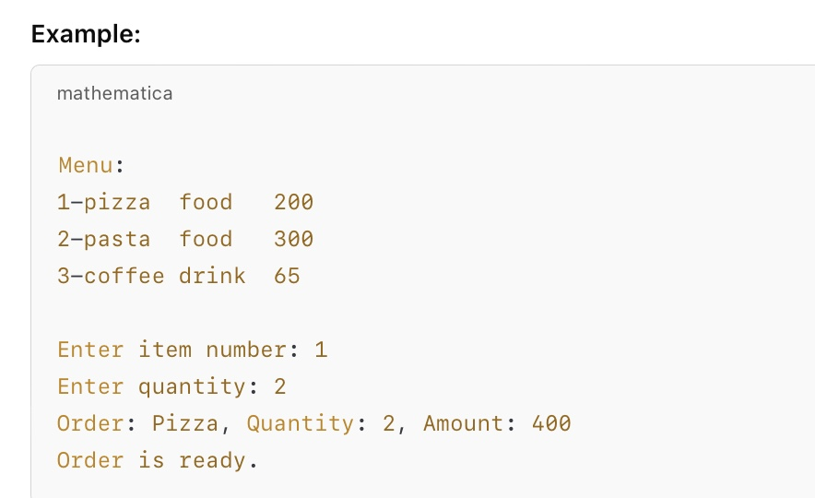
- Create a C++ program to input scores for 5 students, calculate their total score, and display it.

Requirements:
- Input the scores for 5 students.
- Calculate the total score.
- Display the total score.

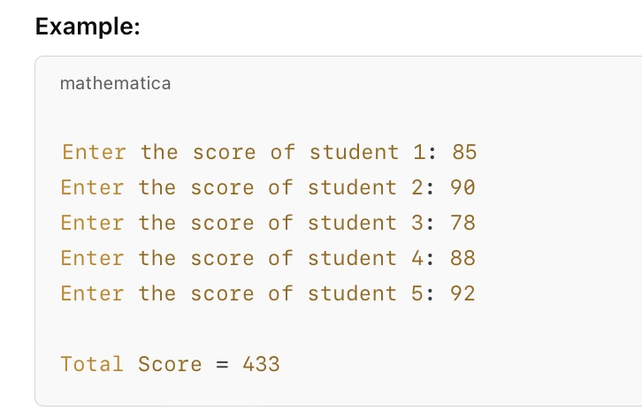

- Create a C++ program that defines a Circle class with a static variable to count the number of objects created. Each object should calculate and display the area of the circle based on its radius.

Requirements:
Class Circle:
  - Private members: radius (int).
  - Static member count to track the number of objects created.
  - Constructor that takes an integer r (radius), increments count, and displays the object number and the area.
  - getarea() method to calculate and return the area using πr2πr2 (with π≈3.142π≈3.142).
Main Function:
  - Input three radii from the user.
  - Create three Circle objects and display the object number and area for each.
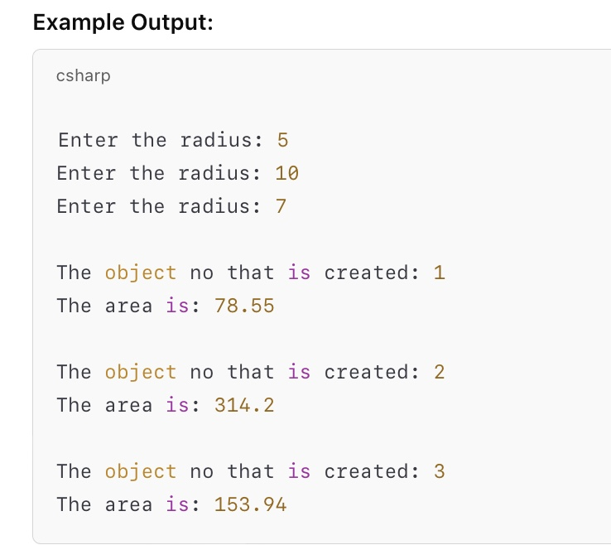

- Write a C++ program that demonstrates the use of a constant member variable and const member function.

Requirements:
Define a class Demos with:
  - A constant integer x initialized in the constructor.
  - A const member function display() that prints "Inside the display function." followed by the value of x.
  - A regular function showMessage() that displays "Inside show message function.".
In main(), create an object d1, initialize it with a value for x, and call showMessage() and display().
- Write a C++ program to demonstrate the use of static variables and static member functions.
Requirements:
Define a class Add with:
  - Two static integer variables a and b.
  - A static member function sum() that:
    - Prompts the user to enter values for a and b.
    - Calculates the sum of a and b.
    - Displays the sum.
In main(), create an object of class Add and call the sum() function.
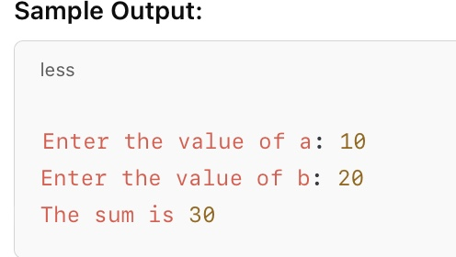
- Design a program that manages information about two books using inheritance. Create a base class Books with attributes for the book name, publisher name, ISBN, and genre. Then, create two derived classes B1 and B2 to input details for two books.

- B1 asks for details of the first book.
- B2 asks for details of the second book.
- In the main() function, display the details for both books
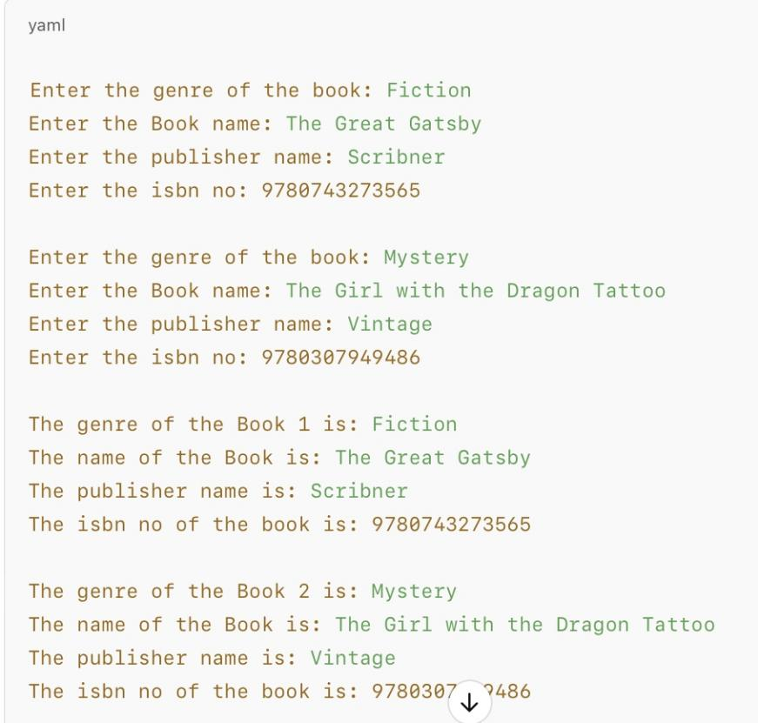

- Design a vehicle management system that models two types of vehicles: a car (Audi) and a motorcycle (Yamaha).
Classes:
1.) Vehicle:
Holds an integer array price[2] for the price of two vehicles: one car and one motorcycle.
2.) Car (Audi):
- Inherits from Vehicle.
- Attributes: seatcapacity, nodoor, ftype, and mtype (model type).
3.) Motorcycle (Yamaha):
- Inherits from Vehicle.
- Attributes: nocy (cylinders), nog (gears), now (wheels), and maketype.

Input Details:
- For Audi: Price, seat capacity, number of doors, fuel type, and model type.
- For Yamaha: Price, number of cylinders, gears, wheels, and make type.
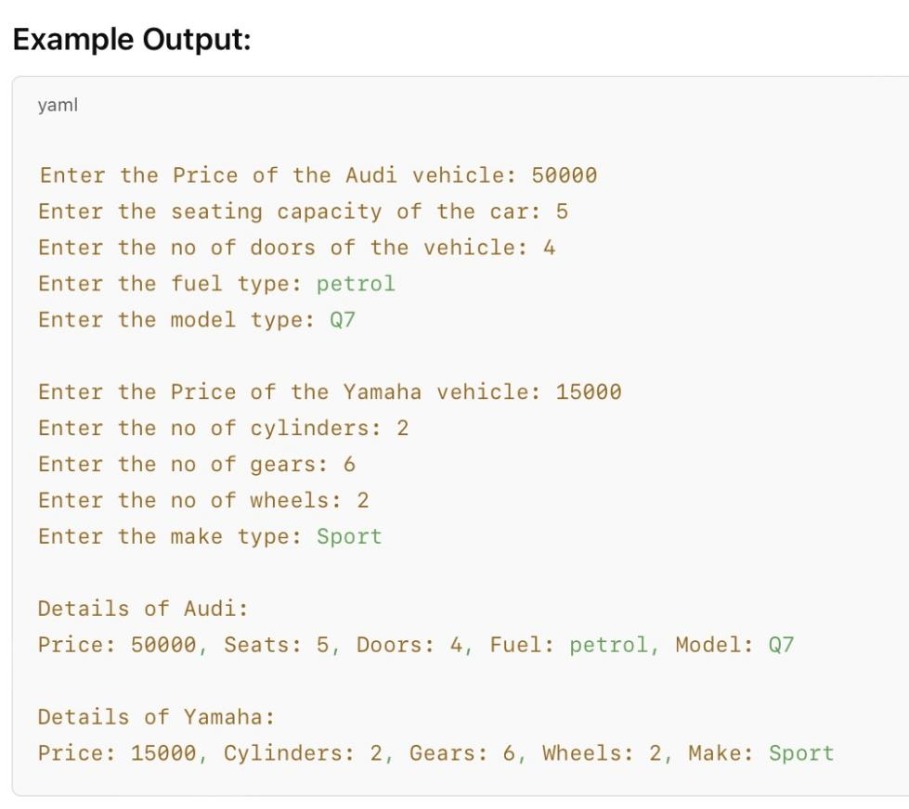

- Create a system to manage student information and calculate their total and average marks using inheritance.
Classes:
1.) Student:
Attributes: name, cls, rollno.
Constructor to input student details.
2.) Marks (Inherits from Student):
Attributes: markse, marksm, marksp (marks for English, Math, and Physics).
Constructor to input marks.

3.) Result (Inherits from Marks):
4.) Methods:
infostd(): Displays student info.
tmarks(): Returns total marks.
avgmarks(): Retrns average marks.
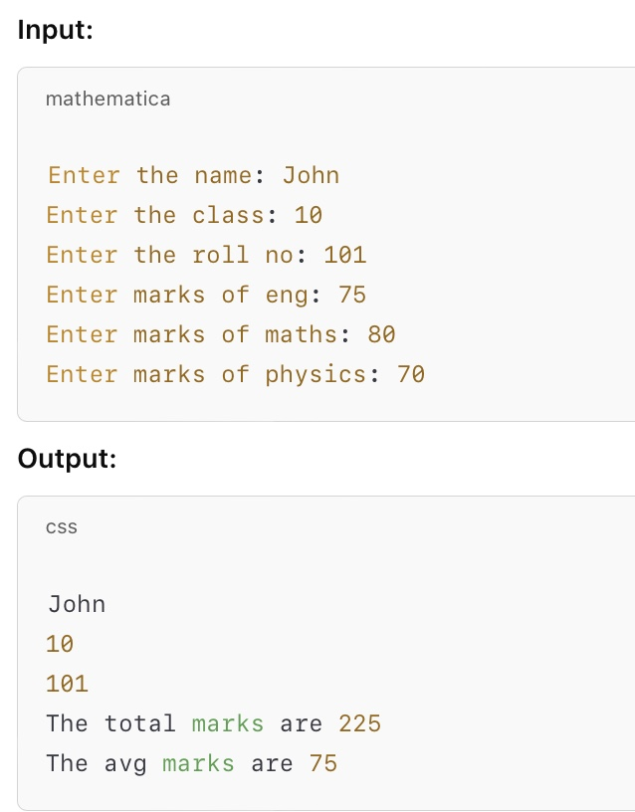
- Create a system to manage student information and calculate their total and average marks using inheritance.

Long Questions

1.) How would you design the ISBN class to validate and parse the four parts of an ISBN string (e.g., 0 941831 39 6)? Implement the constructor and setISBN method to ensure the ISBN string is in the correct format.
How would you implement the Book class to store and display details such as title, author, publisher, price, and the associated ISBN? Write the setBookISBN and printDetails methods to interact with the ISBN class.
2.) Create a class named EmployeeBonus. The fields include the employee's salary, the bonus rate, and the total bonus. Create two constructors. Each constructor requires the salary (expressed as a double) and the bonus rate. One constructor requires the bonus rate to be a double, such as 0.1. The other requires the salary and the bonus rate expressed as a whole number, such as 10. Each constructor calculates the total bonus value based on the employee's salary multiplied by the bonus rate. The difference is that the constructor that accepts the whole number must convert it to a percentage by dividing it by 100.
Also, include a displayBonusDetails function that displays the salary, bonus rate, and total bonus for the employee.
Write a main() function that instantiates at least two EmployeeBonus objects—one that uses a decimal and one that uses a whole number as the bonus rate. Display the EmployeeBonus object values. Save the file as EmployeeBonus.cpp.
3.) Create a class named CarRental:
Include fields for a customer's data as an aggregate object. Create a Customer class that includes fields for name, license number, and contact number. Include a default constructor that initializes name, license number, and contact number to "Unknown" if no arguments are supplied. Also include a displayDetails function to display the customer's information. Write the class definition for a RentalDate class that contains three integer data members: pickupDay, pickupMonth, and pickupYear.
Include a default constructor that assigns the date to 1/1/2023 for any new object that does not receive arguments. Also include a displayDate function to display the rental date.
Write a program that creates and displays:
A Customer object using the default constructor.
A RentalDate object using the default constructor.
Another set of Customer and RentalDate objects using parameterized constructors.

